Castle-Moat.tiff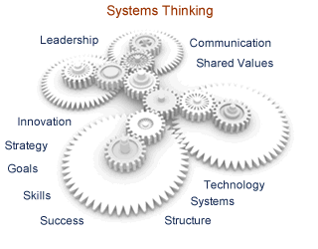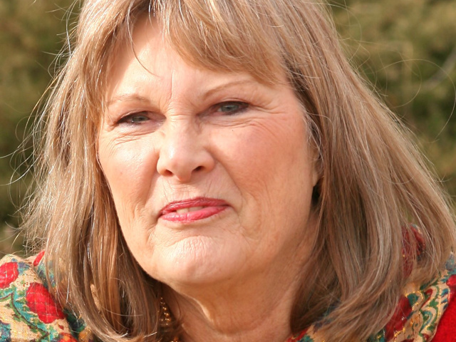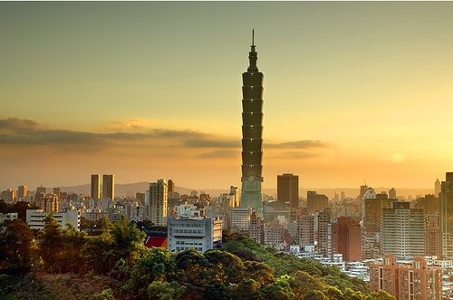Castle-Moat.tiff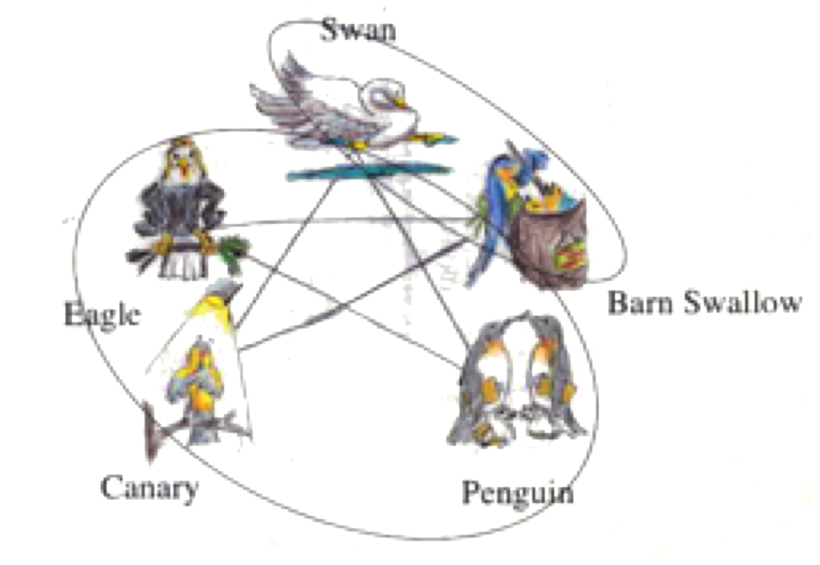

### The Hidden Dynamics of Values

Systems are a collection of parts forming a whole, that come together for a purpose. Each part affects the whole, but not independently and NOT at the same time. The parts are NOT interchangeable.

We are used to thinking of each value as a separate thing, unconnected to anything else. If the dynamics described above applied to values, what would be the impact? What would a system of values look like?

What a person is obligated, or permitted to do in a specific situation or in a particular domain of action.

I have been obsessed by values and trying to better understand why people do what they do – AND why it doesn’t seem to work out as planned. I was captivated by the work of Jane Jacobs. Her positing that values came in systems, she named two, was an eye opener.

Believing that there was a third system trying to born, I developed the Resilient Value Set™ based on the work of Janine Benyus, David Suzuki, Thomas Berry, Wendell Berry, and others.

If we work with the values that sustain nature – we can’t go wrong.

Kathryn Alexander, MA 1819 E. Liberty Ave Spokane, WA 99207-4272  
Phone: (509) 934-5930 Email: Bridge2Partnership@gmail.com

Website: https://BridgeToPartnership.com

## Kathryn Alexander, MA

Values

Bridge To Partnership

Applied Ethics

Rethinking

***Facing a Regenerative Future***

Every system we have is either failing or in dire need of repair. Those who wish to mimic nature talk about the ability to regenerate new systems that are distributive and even ‘generous.’ This means moving beyond zero waste to actually be able to contribute value to the community and the planet.

In the **Resilience Value Set™** The key value as posited by Janine Benyus is , *All actions create the conditions that support Life*. The purpose of this value set is to create and maintain a robust and vibrant ecosystem that is resilient while becoming ever more complex. The need for innovation could not be stronger and it will not be met by values that create an us/them stance or by values that foster competition. The impending changes require a value set that keeps the focus on fostering the conditions in which life thrives, driven by those for whom the joy of Life is precious.

These assessments, combined with the **Birds of a Feather Model,™** help leaders keep their organizations on track. By maintaining a systems look at the impact of various values and needs on leadership and culture we can shift our decision-making to choose Life.

**Please contact us to discuss how these assessments can add value to your organization.**

**Contact Kathryn Alexander, MA**

**(509) 934-5930**

**Bridge2Partnership@gmail.com**

**Visit our website:**

**https://BridgeToPartnership.com**

* *“Regeneration means to make common cause with place, to make our lives fit our places.”* ~ Adapted from Wendell Berry

Our assessments help leaders determine the values that actually *live* in their culture and discover how that may differ from the values *espoused* by the culture. The *Culture and Leadership Survey* ™ uses the *Birds of a Feather™* model to show congruence between the individual and the company, the department or team and the company. The *Strategic Values™* assessment speak to the presence of the Protective™ and Effective Values Sets™, while the Resilience Values Set™ speaks to the level of resilience, regeneration, and innovation in the culture.

Values Determine Actions